Mississippi primaries are Open Primary Elections
  YOU CAN VOTE
   | 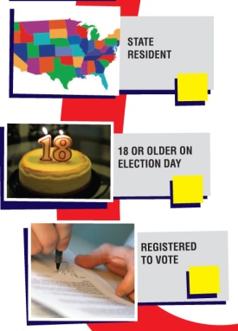 |  | STATE RESIDENT  A resident of the state, county, and supervisor’s district for 30 days  CHECK REGISTRATION  - http://cfl.sos.state.ms.us/webpages/searchpolling.aspx  - Local Circuit Clerk or Municipal Clerk
  WAYS TO REGISTER
   |  |  | BY MAIL  Complete and mail your voter registration application to your local circuit clerk  LOCAL ELECTIONS OFFICE  In person at your local Circuit Clerk (usually in the county courthouse) or Municipal Clerk (usually in City Hall), or when you get your driver’s license at the Department of Public Safety
  VOTER REGISTRATION
   | 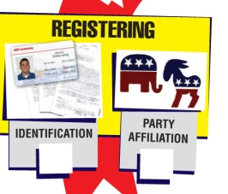 | ID TO REGISTER  - Driver's license number  - Last 4 digits of your Social Security number  - A copy of current valid photo ID  - A copy of a current utility bill Bank statement  - Government check  - Paycheck  - Other government document that  shows your name and address
  REGISTRATION DEADLINE
   |  | BY MAIL / IN PERSON  30 days before an election
  WAYS TO VOTE
   | 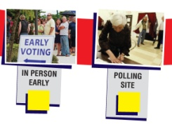 |  |  |  |  |  | POLLING PLACE LOCATOR  - http://cfl.sos.state.ms.us/webpages/searchpolling.aspx  - Local Circuit Clerk or Municipal Clerk
  ELECTION DATES
   |  |  |  | PRIMARY ELECTION:  March 13, 2012  GENERAL ELECTION:  November 6, 2012
   |  |  | VOTER IDENTIFICATION
   |  |  |  |  | MISSISSIPPI DOES HAVE A PHOTO ID REQUIREMENT  Voters are required to show a valid “government issued” photo ID at the poll
   |  |  | PROBLEMS OR QUESTIONS
   |  |  |  |  |  | DISABILITIES RIGHTS MISSISSIPPI  Jackson Office  1 (800) 772-4057 (toll free)  Gulfport Office  1 (855) 604-4455 (toll free) www.disabilityrightsms.com

